# CG scale

General advice

* It’s recommended to assemble the circuit on a breadboard to test all components before soldering permanently
* The Arduino has been pre loaded with the sketch but feel free to request a copy of the Arduino sketch so that you can modify it in the future if needed

You will need:

* All pieces from the kit
* A weight of a precisely known weight (for example, a roll of solder), approximately 500g is recommended – you might need a scale to determine the exact weight.
* Breadboard (optional, for preliminary assembly)
* Solder, flux and soldering iron
* Metric Allen keys
* Scissors
* Dremel or wire cutters to cut piano wire
* 9V battery
* Glue (CA or epoxy)

Assembly & Calibration

1. Assemble the mechanical part of the scale
   1. Bolt the load cells to the frame (the largest plastic piece). Make sure the arrows on the load cells point down.
   2. Bolt the front and rear support to the load cells.
   3. Bolt the load cell cover to the load cells
   4. Install the 4 wing pads on the front and rear supports using small pieces of piano wire. You may need to drill through the pre molded holes.
   5. Put 4 small pieces of felt on top of the wing pads
   6. Insert piano wire vertically into the two holes at the front of the front support, secure with a drop of glue

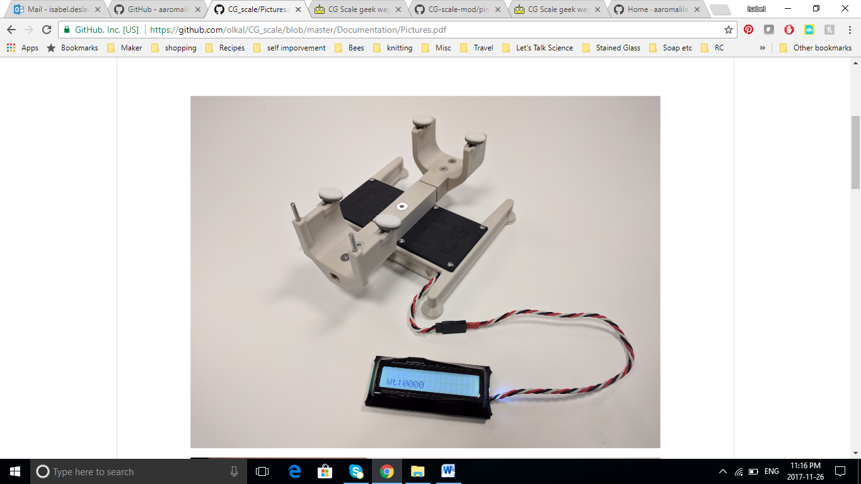

1. Assemble the circuit according to the diagram below

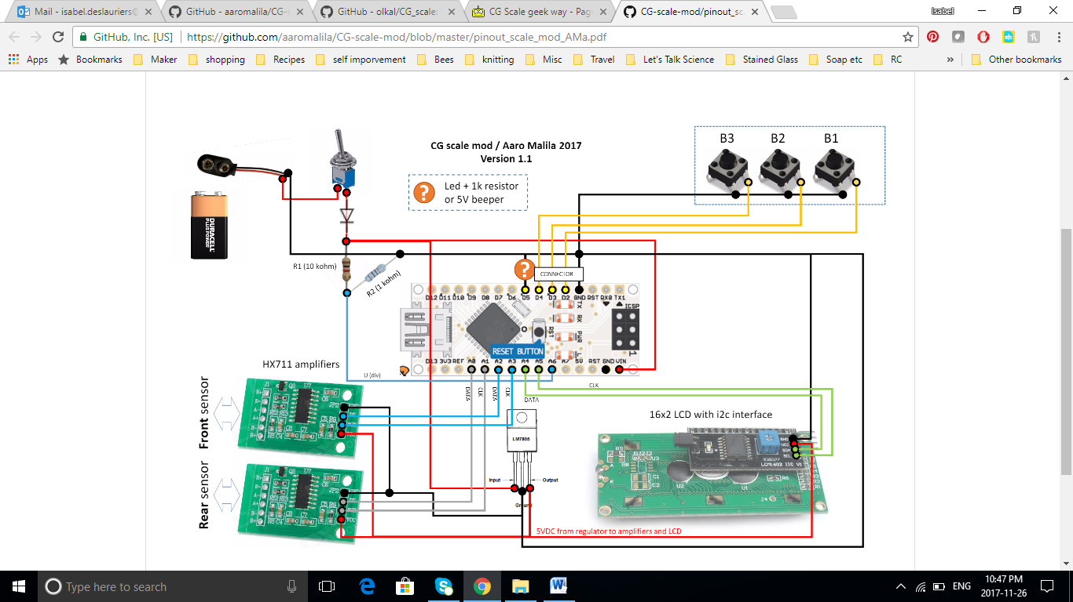

Notes on circuit diagram:

* R1 and R2 are optional, only used if you want to monitor the voltage of the battery.
* The orange question mark is a Led in series with a 1k resistor
* “connector” can be any 4 pin connector, or hardwired. The kit only provides you with a hard wire option. If you wish to have a detachable display, you must supply your own 4 pin connector.

1. While pressing down button 1, turn on the circuit (by plugging in the battery) – you only need to do this the first time you turn on the scale to avoid “NaN” errors.
2. If you can’t see anything on the display, adjust the contrast using the screw adjustment on the back of the LCD screen.
3. Put your known weight on the white U bracket, and put the U bracket on the front support.

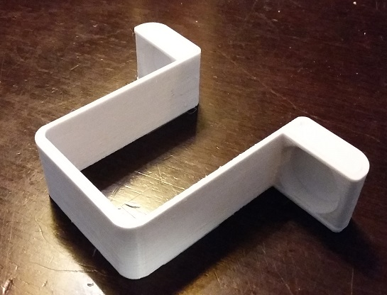

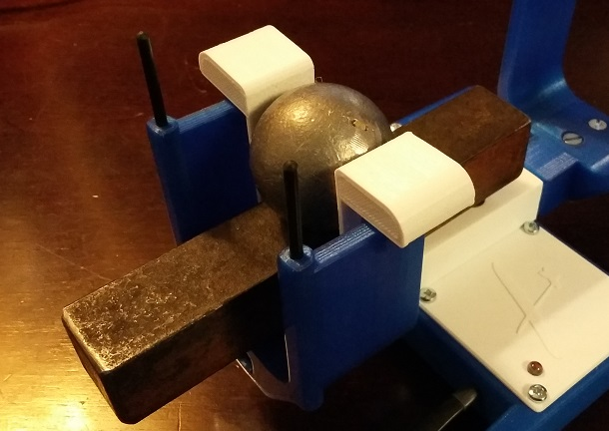

1. Wait until the display stabilizes, then press button 1 for a couple seconds, until you see “Calibrate?” appear. If it doesn’t appear, try pressing button one again for a couple seconds.
2. Once you get “Calibrate?”, press button 1 to enter calibration

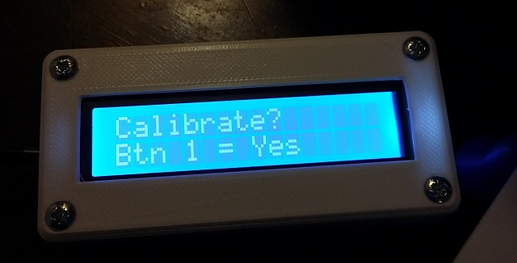

1. Using button 2 and button 3, increase or decrease the weight shown until the display shows roughly the known weight value. Press 1, and then again use button 2 and 3 again to approximate the weight better; press 1 and use button 2 and 3 one last time to get as close as possible to the known weight, press 1 one last time.

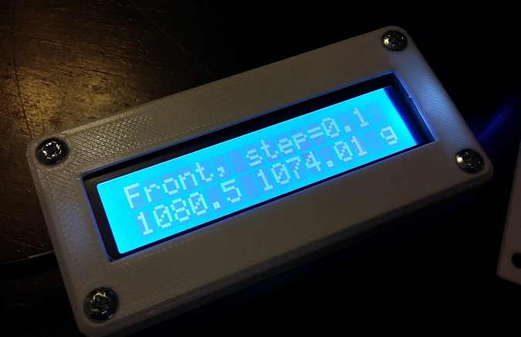

1. Move the known weight to the rear support.
2. Repeat step 6 to calibrate the rear load cell.
3. The last time you press button 1, you will see a message “saving values”.

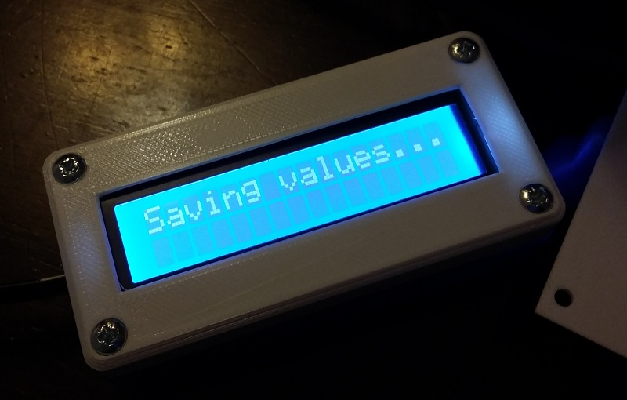

1. Test your scale with an actual glider – make sure the leading edge is pressed against the piano wire at the front, and that the glider isn’t touching the support or the table anywhere except the 4 pads. Compare the CG to a manually calculated CG – if there is a discrepancy of more than 1mm, repeat the calibration procedure.

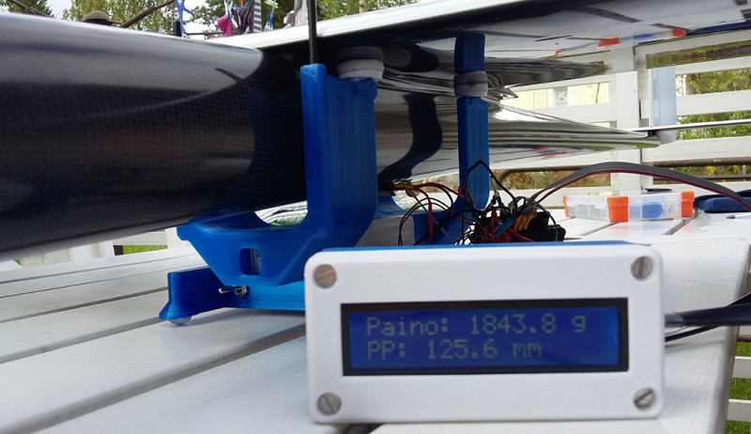

1. Once everything is working, remove the circuit from the breadboard and permanently solder it. Make sure to plan your wiring so that everything can fit properly into the frame.
2. Insert the electronics into the frame.

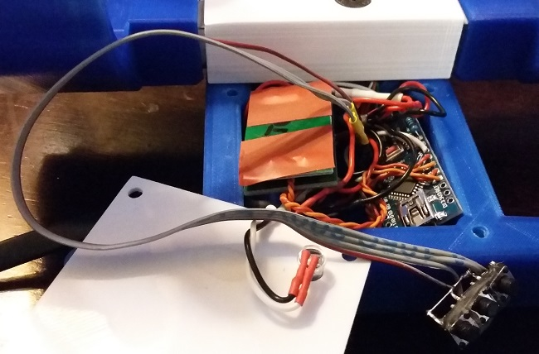

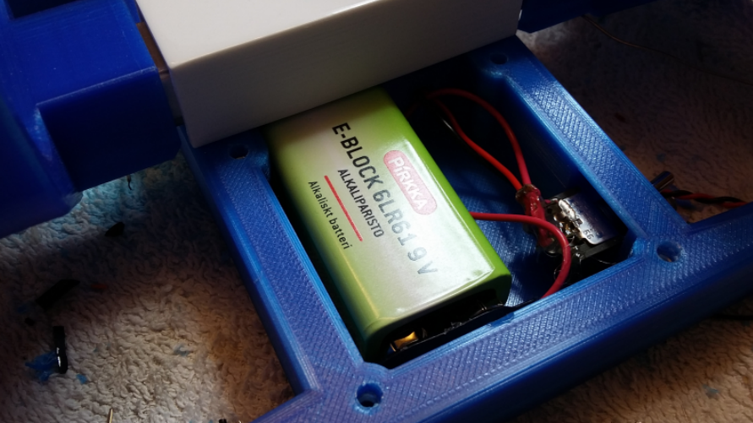

1. Insert the screen into the screen casing and bolt it together.
2. Test everything again!

I added the rest of the group to this "build thread". If anyone wants to removed and wait until v2.0 of the instructions you can tell us :) Keep sending info/questions,  I can keep track and modify the draft instructions. When a couple people are done I can circulate a new version.

For the load cell, on the prototype I have green to a- and white to a+ (so reverse from what Duc says, I am not sure offhand if it matters). After a quick Google search yes it looks like e+ is vcc (so red) and e- is ground (so black). Its a good idea to protect the load cell wires, they are very delicate...I had mine break once during prototyping.

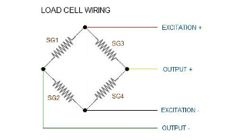

Stephane was going to mail pushbuttons and pianowire I think, probably after the holidays? However I have some buttons here (from my christmas stocking, haha) if anyone passes by and wants them, I can spare a few. Any momentary switch will do, you are right, Alex.

Note that the switches are only needed for calibration so you don't necessarily have to have them hardwired and inside the compartment- if you want they could be temporarily connected (with old servo extension for example) during calibration.

One screw for the load cells should be fine, that is what i had for most of my testing, until I found more screws.  You could drill a hole if you prefer but not really necessary. You can cut off the end of the screw that is too long with dremel cutoff wheel or grinder if needed. I could fill in the unused hole with same color filament and a 3d printing pen once assembled, if anyone wants better aesthetics :).

For the lcd back, I can design and print a new backing that will clamshell to the front but I will need to borrow the lcd from one kit, sounds like they are a bit different from the one in the prototype. I guess it's Murphys law,  the electronics parts I had all fit exactly with the 3d files from github but I suppose they are not standard :s . I am not sure I completely understand the fit but to use it temporarily you could maybe cut of melt an opening for the header. It's also fine to temporarily use the lcd without a casing. Anyways I will make a new version when I can get ahold of one kit (maybe the unsold one?)

If you end up drilling anything (it will probably be necessary to at least clean the holes a bit for the piano wire, just keep in mind that the plastic melts very, very easily so go slow :)

Sent from Samsung tablet

-------- Original message --------  
From: Duc LeVan <levand@outlook.com>   
Date: 12-31-2017 5:24 PM (GMT-05:00)   
To: Blissful Happy Puppy <tsoukan@hotmail.com>   
Cc: "Isabel Deslauriers, Ms" <isabel.deslauriers@mail.mcgill.ca>, Stephane Monfette <stephane.monfette@sympatico.ca>, paul.charlebois@videotron.ca   
Subject: Re: C of G machine   
  
Hi Alex

I started this morning and also found a few things like you: holes do not match with load cell: I think one screw is fine: the number of screws just match ! The extra screws you find are probable for the exact same model of load cells used by the original design.

The kit does not have the 3 switches . I bought mine than lost them somewhere !

I did not test the fitting of the panel but found the screws for the casing toi shorts. I have to drill to get them to work .

For the load cell connection to the amplifier: twist the wires to eliminate noises, then connect: Red to E+, Black to E-, White to A-, Green to A+. Oups: you are right: our boards must have Out+ = E+ and Ground = E- . Isabel, can you confirm ?

I plan to have the battery, voltage regulator, switch and the 3 button switches hot glued to a popsicle stick in one compartment. I also plan to solder the 2 amplifier with a header at the supply pins to weld them together with a piece of thin insulating cardboard, then shrink wrap them. Along with the bare Arduino and loose wirings will be housed in the second compartment.

What is your planned layout ?

Let us know if you find a solution for the panel casing.

Happy New year,

Duc

Ps: Stephane: What is the size of the piano wire ?

Sent from my iPhone

On Dec 31, 2017, at 16:26, Blissful Happy Puppy <[tsoukan@hotmail.com](mailto:tsoukan@hotmail.com)> wrote:

I have a few questions.

What is the minimum plane weight that this should work for?  Based on the load cells I know the Max will be a bit less than 6kg.

What size piano wire is needed for assembly?

As I was assembling the kit and encountered some issues.

1. The kit was missing the 3 buttons.  I take it they are just momentary push button type switches, if so I think I have some in my parts bin. Where is the recommended/suggested mounting location?
2. The holes in the printed parts and the loads cells don’t match up.  I can get one screw in each load cell which I think should be enough given the weights we will be dealing with.
3. The display does not fit in the case.  The front half of the case it perfect, the back half is not deep enough and the corner filet interfers with the 4 pin header.  
   <E5217DB194984616B4BF407FA614DFD7.jpg>
4. Do you have the wiring diagram for the load cells and amplifiers so I know which wire goes to which pins?  This is my guess, can you confirm?
   1. Out+      <> red
   2. A-            <> white
   3. A+          <> green
   4. GND      <> black

I also have extra/missing screws.  This missing ones are easy since I likely have them in my parts bin.  I would like to know it if the extra ones are used somewhere not documented in the assembly or it I can toss them in the parts bin.<E5420318B75E48A6A9A6D220CCA3053F.jpg>

1. 4 large M5 x 20mm appear to be extra
2. M5 x 7mm and M4 x 15mm.  The M5 appears to be extra, the M4 was to be used to fasten the cover over the load cells but is a bit too long and bottoms out one the screw holding the load cell.
3. The screws to hold the covers on the base – not extra
4. The screws to hold the display case together – missing 3.

Thanks again for letting me in on this.  I know Jean, I and maybe some of the other Ottawa guys will put it to good use.

Have a Happy New Year!!!

Alex

**From:** Duc LeVan <[levand@outlook.com](mailto:levand@outlook.com)>  
**Sent:** Wednesday, December 20, 2017 9:37:30 PM  
**To:** Blissful Happy Puppy; Isabel Deslauriers, Ms  
**Cc:** Fabien Gagné  
**Subject:** Re: C of G machine

Hi Alex

We met this evening and I got your kit. I will give it to you when you come for to Jacques' place for bagging.

You have to send $42.26 to Isabel using Interac.

For now, attached are the instructions for you to study. And here is the picture of Isabel's working prototype:

<IMG_2565.jpg>

Duc

**From:** Blissful Happy Puppy <[tsoukan@hotmail.com](mailto:tsoukan@hotmail.com)>  
**Sent:** December 18, 2017 11:50 AM  
**To:** Duc LeVan; Isabel Deslauriers, Ms  
**Subject:** Re: C of G machine

I'll be at Jacques in MTL on the 27th. If you can get it to him without much trouble that would be great, otherwise I can pick it up on my way home that evening if your around.

Alex.

From: Isabel Deslauriers, Ms

Sent: Saturday, December 16, 5:21 PM

Subject: Re: C of G machine

To: Duc LeVan, Kijiji Ottawa

It's all finished, we just have to meet up to bag the kits (different people have different parts of it), should happen this week. For the price we still need to add up the individual parts cost so we can get back to you shortly! I can keep the extra with me since I'm closer to Ottawa.

Get [Outlook for Android](https://eur01.safelinks.protection.outlook.com/?url=https%3A%2F%2Faka.ms%2Fghei36&data=02%7C01%7C%7Cc8c8d2865f0847b8aaff08d5481be0b2%7C84df9e7fe9f640afb435aaaaaaaaaaaa%7C1%7C0%7C636494207901833911&sdata=JrqPeqWmC8h8pud74HkZDyGwM%2B%2BA4mIeXhjDNyQ4PEU%3D&reserved=0)

From: Kijiji Ottawa

Sent: Saturday, December 16, 16:55

Subject: Re: C of G machine

To: Duc LeVan, Isabel Deslauriers, Ms

Awesome!! Are you still making them or is it done? How much do I owe?

Alex

**From:** Isabel Deslauriers, Ms <[isabel.deslauriers@mail.mcgill.ca](mailto:isabel.deslauriers@mail.mcgill.ca)>

**Sent:** Saturday, December 16, 2017 2:41:29 PM

**To:** Duc LeVan; Kijiji Ottawa

**Subject:** Re: C of G machine

Ok I'll reserve him the last one!

Get [Outlook for Android](https://eur01.safelinks.protection.outlook.com/?url=https%3A%2F%2Faka.ms%2Fghei36&data=02%7C01%7C%7Cc8c8d2865f0847b8aaff08d5481be0b2%7C84df9e7fe9f640afb435aaaaaaaaaaaa%7C1%7C0%7C636494207901833911&sdata=JrqPeqWmC8h8pud74HkZDyGwM%2B%2BA4mIeXhjDNyQ4PEU%3D&reserved=0)

**From:** Kijiji Ottawa <[kijiji-ottawa@outlook.com](mailto:kijiji-ottawa@outlook.com)>

**Sent:** Saturday, December 16, 2017 2:04:19 PM

**To:** Isabel Deslauriers, Ms; Duc LeVan

**Subject:** Re: C of G machine

Yes please.

Also it would appear I sent the email with the wrong address earlier. My usual address is [tsoukan@hotmail.com](mailto:tsoukan@hotmail.com) - the Bissful Happy Puppy!

**From:** Duc LeVan <levand@outlook.com>

**Sent:** Saturday, December 16, 2017 1:44:36 PM

**To:** Kijiji Ottawa; [isabel.deslauriers@mail.mcgill.ca](mailto:isabel.deslauriers@mail.mcgill.ca)

**Subject:** Re: C of G machine

Isabel

Alex would like to get your extra CG unit. That would be great having one unit in Ottawa.

Duc

Sent from my iPhone

On Dec 16, 2017, at 12:50, Kijiji Ottawa <[kijiji-ottawa@outlook.com](mailto:kijiji-ottawa@outlook.com)> wrote:

It was really nice meeting you last weekend. Did you have a chance to see if there was an unspoken for electronic C of G machine?  If not can you share the BOM, Arduino code and other details so I can make one myself.

Thanks,

Alex